7th January, 2021

Hon. Dr. Keith Rowley
Office of the Prime Minister
15 St. Clair Avenue,
Port-of-Spain,
Trinidad and Tobago.

Dear Prime Minister Hon. Dr. Rowley,

Warm greetings of peace, goodwill, good health and wellbeing for 2021.

On behalf of the political opposition in Guyana and all Guyanese I extend best wishes to you as you assume the Chairmanship of CARICOM.

We are confident that as Chairman you will attend to matters which are both of concern and distress to the people of the region and to pursue solutions in their best interest.

I thank you for the keen interest you have shown in Guyana generally and specifically with regard to the events of 2020 which we maintain have resulted in the installation of a new government, the legitimacy of which we are challenging this by way of election petitions before the High Court.

In addition to this issue which impales and impairs democracy in Guyana the PPP administration has embarked on an unmistakable and vicious campaign, including firing over 1000 Afro-Guyanese public servants without just cause or basis. Many of these are single mothers who are the sole breadwinners of their households. Innocent apolitical Afro-Guyanese professionals are being persecuted, dubiously arrested and charged on trumped up charges.

Further the heinous murder of two young Afro-Guyanese boys and their Indo-Guyanese friend has remained unsolved months later and the regime has shown little interest in providing the resources and engaging in the collaboration to bring closure and pursue justice. These brutal murders and the marking of X’s in the skulls of the two boys have outraged Guyanese of all walks of life, yet their murderers are free and unbothered.

Hon. Chairman, I have previously informed you of the unravelling of democratic values in Guyana since August 2nd, 2020 and I will provide you with a detailed update in subsequent documents. These will include the PPP administration’s disregard for the Constitution and their shameless distribution of funds approved by the National Assembly for COVID-19 relief for all Guyanese households, but distributed by and to primarily supporters of the PPP.

I look forward to engaging with you to discuss these and other critical matters in the near future, even if virtually as necessitated by the circumstances.

Finally, I commend you on your stewardship of Trinidad and Tobago with regard to containing the spread of COVID-19 and your bold and necessary decisions to keep your borders closed. This is no doubt a demonstration of prudent leadership which I am confident you will bring to the chairmanship of CARICOM during your tenure.

As you have articulated in your Chairman’s message, we must emerge from the darkness of the past year and emerge into the light of 2021. We look forward to your leadership, support and advocacy in the issues of democracy and justice in Guyana.

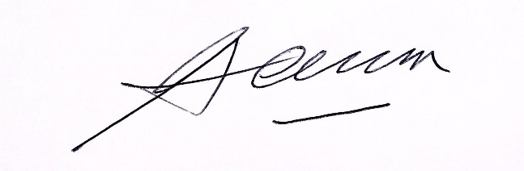
Yours sincerely,

………………………………….
Joseph F. Harmon MSM, MP
Leader of the Opposition
Cooperative Republic of Guyana

